

Concept Paper on IT Management of
Center for Economic and Social Development

This Concept paper was prepared within the project titled “Core and Institutional Support” funded by Think Tank Fund,Hungary.

BAKI July 2010

Center for Economic and Social Development
Dilara Aliyeva 115,
Baku Az1009,Azərbaycan
Tel: (99412) 597 0691
Fax: (99412) 437 3240
Email: cesd@aztelekom.net
cesd.az@gmail.com
Web: http://www.cesd.az

Introduction

The use of information and communication technology (ICT) can enhance the development chances of Azeri Civil Society Organizations (CSOs).
Although this factor seems so significant for future development, still vast majority of CSOs cannot fully carry out some activities regarding the development of ICT ( site, internal communication, information sharing etc.) that can lead them to be more sustainable.
CSOs with existing web portals/sites experience financial insufficiency to constanly renew and update their sites. As a result of this poor situation, many people confront serious problems and eventually become deprived to get new necessary information (social, economic, and regional) that concerns Civil Society.
These kinds of issues make CSOs’ efforts to influence the public opinion more vulnerable by lowering their chances to use advocacy and media tools. Current level of Access to Public Information in Azerbaijan also creates very undesirable situation for local and foreign reasearches who aim to achieve information about Azeri Cvil Society Organizations.
We, Center for Economic and Social Development which aims to promote research and analysis into the domestic economy, the use of new internet communication communication technologies is particularly significant issue.

With the help of “Core and Institutional Support” grant program from Think Tank Fond the Center for Economic and Social Development (CESD) was able to renew its site and offer more useable and broder information to the site visitors. CESD web site has become one of trusted information source since the website includes daily economic comments, analysis, news, reports and etc.

Background Information

CESD ( Center for Economic and Social Development- www.cesd.az) website was lunched in 2007. In last 3 years the website was renewed and redesigned twicely and now it supports the modern requirements of WEB world.

From its inception period the site conveyed only little information about the Center, its staff, structure and implemented projects. The site was offered only in one language ( English).
As the below gragh shows, number of monthly new visitors before the “Core and Institutional Support” program were quite low.

Graph 1
Mənbə. Yahoo Counter

Current Situation
After the implementation of “Core and Institutional Support” program, CESD website has been renewed and now it serves as a main source of daily economic comments,analysis and news for civil society members.
CESD web-site is most often attended and cited among economic think tanks in Azerbaijan
According to the Yahoo Counter, number of new visitors to the CESD web-site has been 5 times increased in April, 2010 compare with December, 2009

CESD has the most often attended and cited website among think tanks in Azerbaijan on policy issues. According to the Yahoo Counter, number of new visitors to the CESD web-site (www.cesd.az) has been 5 times increased in April, 2010 compare with December, 2009. 4 000 new visitors, totally more than 10 000 visitors monthly use CESD web-site.

This graph illustrates the increase in number of new visitors.
Graph 2
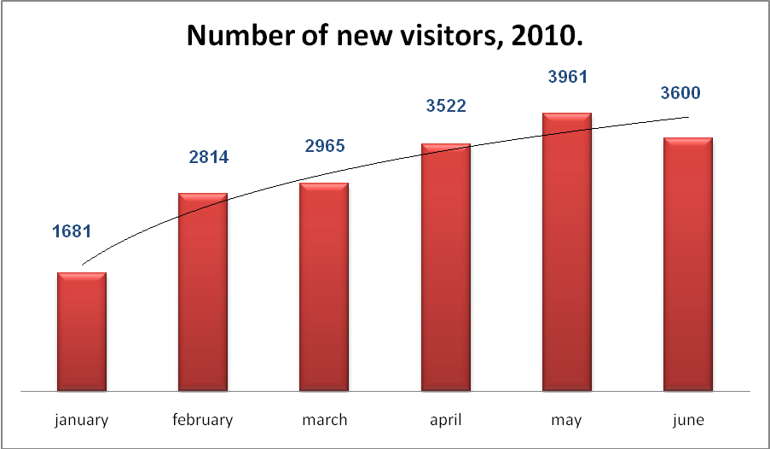
Source Yahoo Counter

Thanks to Core and Institutional Support from OSI Think Tank Fund, CESD web-site was re-established and daily updated. Now CESD uses the Think Tank Fund support for the database and access system development, and for the improvement of the website to regularly provide updated and more comprehensive information on socio-economic activities within and beyond the Center, as well as to serve as a necessary source of information for the scholars, within or interested with Azerbaijan and the region. Apart from socio-economic data and researches, it is also provided information on public institutes and involve more partners, especially who are interested in research and programs in Azerbaijan and the region. By improving its website the CESD is able to provide necessary domestic and regional social and economic updates in English, Russian and Azeri.
Within last 4 months we produced 110, 75, and 58 economic articles, comments respectively in Azeri, English, and Russian. Morever, we did our best to show how we are accountable, transparent, and open by disclosuring all information about the projects we implement documents. CESD IT management tries to conform all its activities in a way that it supports the mission and strategy of the organization. For more transparency and accountability purposes CESD website contains the following project related information:
- Information on the projects implemented by CESD.
- More information about the projects: scope, objectives, newsletters, press releases, reports.
- Trainings organized within projects, necessary electronic texts,materials and publications.
- New activities, and financial disclosure. And other important news.

With the help of Core and Institutional Support program CESD offers new opportunites to NGO sector and Media by tightening effective cooperation. Local NGO’s can benefit from the resources (publications, articles, economic news and comments etc.) posted on CESD website. Daily updated site with bunch of information also serves as a very effective tool for decision makers, especially government bodies. As a leading economic think tank in Azerbaijan CESD every year produces policy papers with suggestion to government bodies to improve their current activities in socio econonomic sphere. As a result of these activities, CESD recommendations several times approved by the government.

Furthermore, CESD is closely working with volunteers. 14 volunteers are actively involved in current activities of the Center, and we expect the figure to get larger by several times in next years. The Center also attracts interns to research and other activities during their academic breaks, and is planning to further develop this practice. This summer we are offering 3 internship places( 2 for foriegn researchers and students, 1 for local students). To build a more developed communication system among volunteers, interns and staff members plays has very significance toward buildin a more sustainable organization. At the same time CESD is trying to serve as Economic school for young people by being part of their development through training them how to write economic articles and so on. All these activities were carried out within CESD website.
Apart from the improvement of the Center’s website (www.cesd.az), we are thinking of to launch the complementary websites ( concerning the State Budget, and Civil Society strengthening) which can be crucial source not only for government and civil society institutes but also for mass-media and improve the public awareness, dialog and participation in policymaking and implementation.

Further development opportunities

- To increase the capacity of the website by uploading more training materials; economic news, comments, and analysis
- Web Forum
- Media Part of the site. Videoes, Audio podcasts from the past events
- To build the alternative blog only for economic comments by the Center
- Online economic writing competitions
- To train young economists on how to write blog
- Uploading interesting talks to site on business, technology, entrepreneurship, politics, and economics which concern Civil Society ( for example TEDTalks www.ted.com). To translate talks into the Azeri
- To disseminate information about the center’s researches, monitoring results in different social networks ( Yahoo groups, Student and professional Networks)
- To build more effective internal communication system among interns, staff members, board members and volunteers ( file sharing system, business email, database etc.)

